INTERNSHIP PROJECT

NAME – ATIF ANSARI

TITLE – BASIC PORT SCANNER

CLASS- SY B.VOC (CSDF)

DATE –09 JUNE 2026

INTRODUCTION

In modern computer networks, communication between devices takes place through ports, which act as virtual endpoints for various services and applications. Every network-enabled device uses ports to send and receive data over the internet or a local network. Common services such as web servers, email servers, file transfer services, and remote access applications operate through specific port numbers. Understanding these ports is essential for network administration, troubleshooting, and cybersecurity.

Port scanning is a technique used to identify open, closed, or filtered ports on a target system. It is one of the most fundamental methods used in network reconnaissance and security assessment. By determining which ports are open, security professionals can identify active services running on a system and evaluate potential security risks. Open ports may indicate services that require monitoring, updates, or additional security measures to prevent unauthorized access.

The Basic Port Scanner project focuses on developing a simple tool that scans a target host and checks the status of selected ports.

OBJECTIVE
The primary objective of this project is to design and develop a Basic Port Scanner using Python to identify open ports on a target system. The project aims to provide practical knowledge of network communication and cybersecurity concepts by demonstrating how ports are used by various services and applications.

The specific objectives of this project are:

1. To understand the role of ports in computer networking and data communication.
2. To learn the fundamentals of socket programming using Python.
3. To develop a tool that can scan a range of ports on a target host.
4. To identify and display open ports running active network services.
5. To gain hands-on experience in network reconnaissance techniques used in cybersecurity.
6. To understand the importance of port scanning in network security assessment and vulnerability identification.
7. To improve programming, problem-solving, and analytical skills through practical implementation.

PRACTICAL ANALYSIS

STEP-1 create file
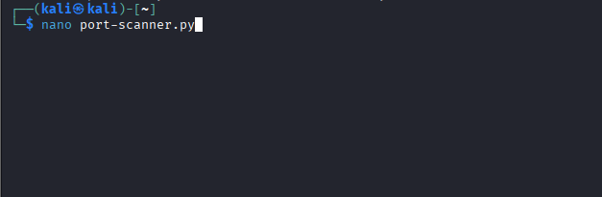

Step 2 – write the python code

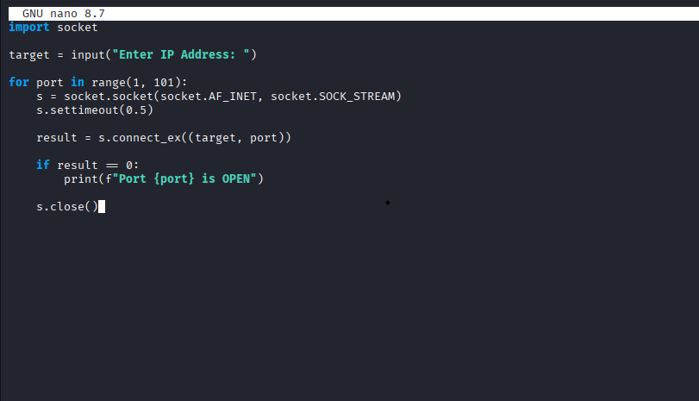

Step3- execute the port scanner
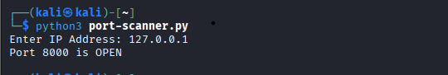
A Python-based port scanner was developed using the socket library. The scanner was configured to scan a range of ports on the localhost address (127.0.0.1). Initially, no open ports were detected because no services were running on the system. To test the scanner, a temporary web server was started using the command "python3 -m http.server 8000".

After starting the web server, the port scanner was executed again. The scanner successfully identified Port 8000 as open, confirming that the web server was actively listening for incoming connections. This demonstrated the scanner's ability to detect active network services and verify port status accurately.

The experiment provided practical experience in socket programming, network communication, and basic reconnaissance techniques used in cybersecurity. The successful detection of an open port validated the functionality of the developed port scanner.

CONCLUSION
The Basic Port Scanner project was successfully implemented using Python. The scanner was able to identify open ports on a target system by attempting network connections to a specified range of ports. During testing, the scanner successfully detected Port 8000 when a local web server was running, demonstrating its effectiveness in identifying active services.

This project helped in understanding network ports, socket programming, and the role of port scanning in cybersecurity. It also provided practical exposure to network reconnaissance techniques and strengthened knowledge of computer networking concepts. The project serves as a foundation for learning advanced network security and vulnerability assessment techniques.

